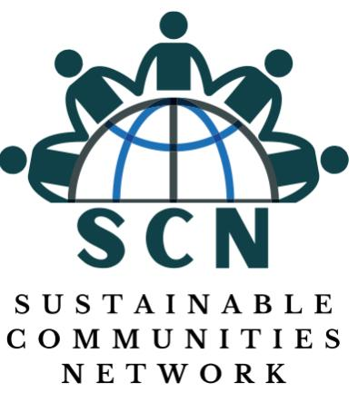

**Sustainable Communities Network (SCN) Quarterly Report -** **Reporting Period: April - June 2024**

**To:**

**NGO Desk Officer**

**Ministry of Youth Affairs**

**Introduction:** This report provides a detailed overview of the activities and initiatives undertaken by Sustainable Communities Network (SCN) from April to June 2024. During this period, SCN has been actively engaged in various community development and empowerment programs, focusing on drug and substance abuse sensitization, digital literacy, community collaboration, and environmental cleanliness. Our efforts aim to foster a healthier, more educated, and united community.

**1. Drug and Substance Abuse Sensitization March (May 11, 2024):** On May 11, 2024, SCN, in collaboration with Youth in Actions Against Drugs (YAAD), organized a significant sensitization march against drug and substance abuse, with a particular emphasis on the dangers of Kush, a potent and harmful drug gaining prevalence in our communities. The march aimed to raise awareness about the devastating effects of drug abuse on individuals, families, and society at large.

The event commenced with a gathering at the Cole Farm Community, where community leaders, health professionals, and recovering addicts shared their insights and personal stories. The procession then moved through the streets of Wilkinson Road, Sir Samuel Lewis Road, Beach Road in Aberdeen, ending up at Kallon Car Park Lumley Beach engaging with residents along the way.

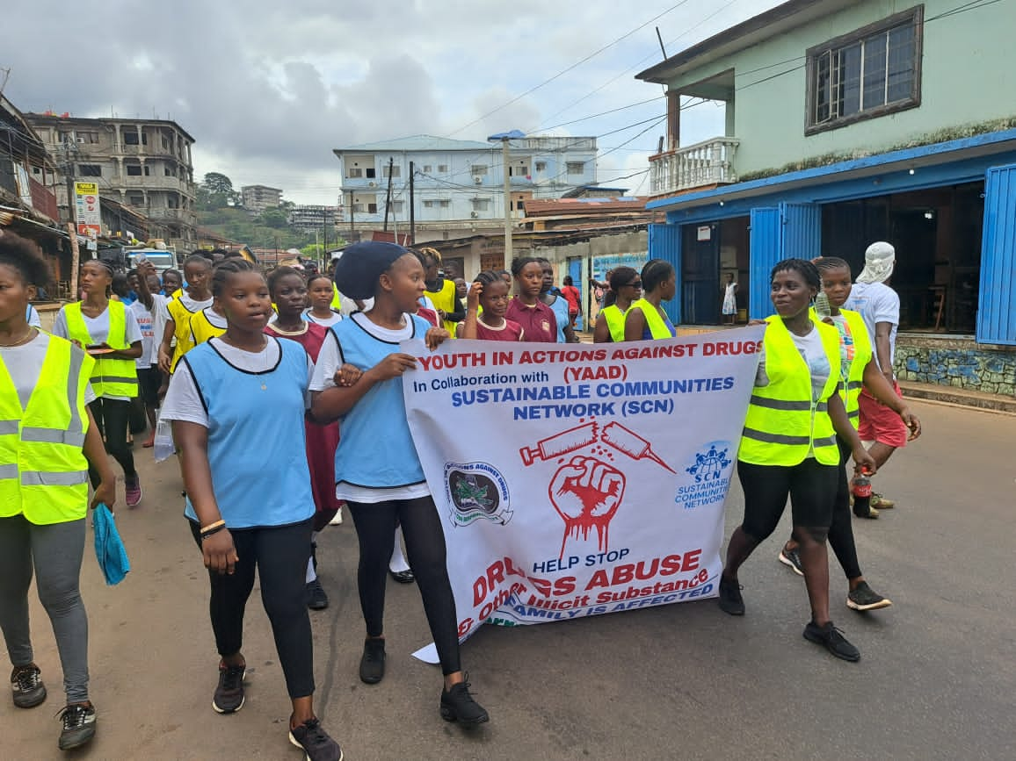

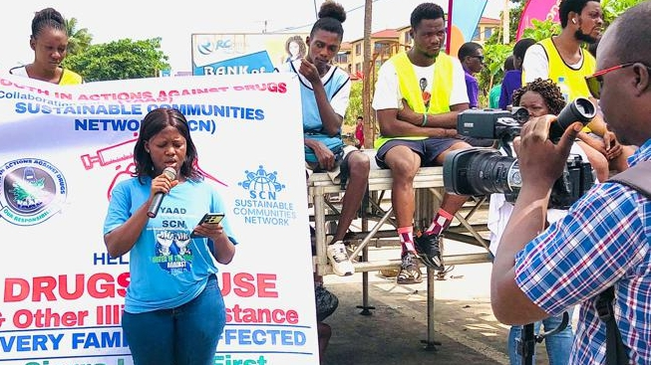

Key highlights of the march included:

* **Community Engagement:** Active participation from community members, including youth, parents, and local leaders, demonstrating a united front against drug abuse.
* **Educational Outreach:** Distribution of pamphlets containing information on the dangers of Kush, signs of addiction, and resources for seeking help, and PA System with drug prevention messages played alongside the march.
* **Media Coverage:** Local media outlets like AYV, SLBC, and RISE Radio covered the event, amplifying the message and reaching a broader audience.

The march successfully fostered a sense of solidarity and urgency, encouraging community members to take proactive steps in combating drug abuse.

**2. Kick Start of the Digital Platform Centre (DPC) (May 21, 2024):** On May 21, 2024, SCN proudly Kick Started the Digital Platform Centre (DPC), an initiative designed to bridge the digital divide and complement the government’s free quality education program. The DPC provides free computer lessons to you of the Cole Farm community and its environs, with a focus on equipping participants with essential basic computer skills.

This precedes the formal launching at a date to be announced. Key features of the DPC include:

* **Curriculum:** The DPC offers comprehensive modules in digital literacy, introduction to ICT, cyber security awareness, and Microsoft Office Suite. These courses are tailored to meet the needs of various age groups and skill levels.
* **State-of-the-Art Facilities:** The centre is equipped with modern computers, high-speed internet, and educational software, providing a conducive learning environment.
* **Qualified Instructors:** Experienced instructors as volunteers lead the training sessions, ensuring high-quality education and personalized attention.

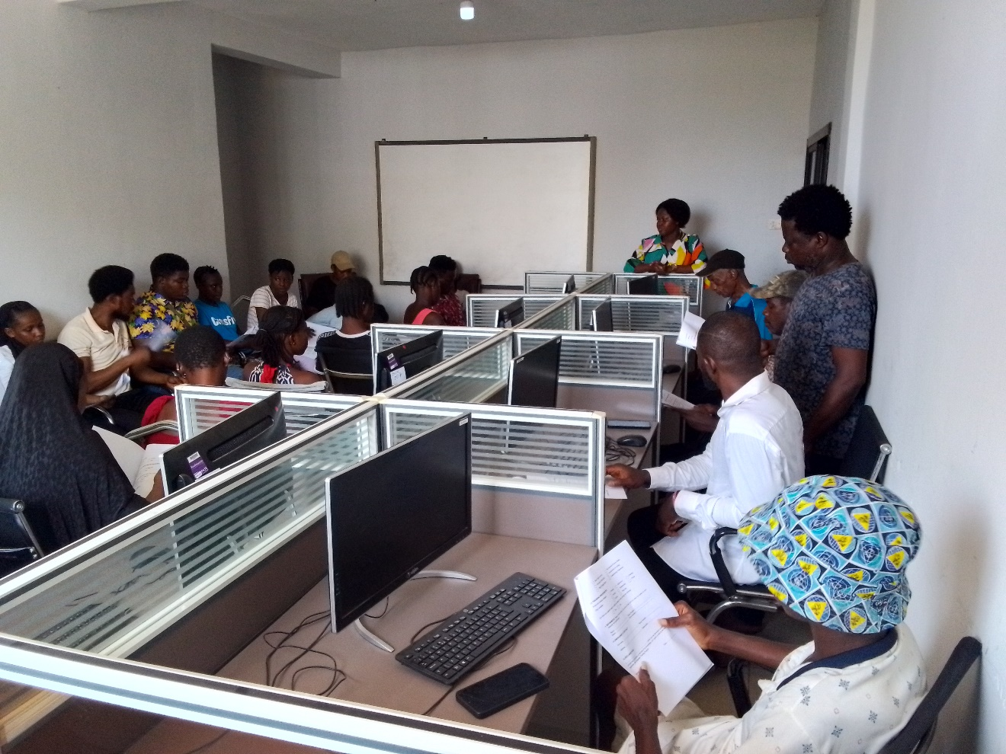

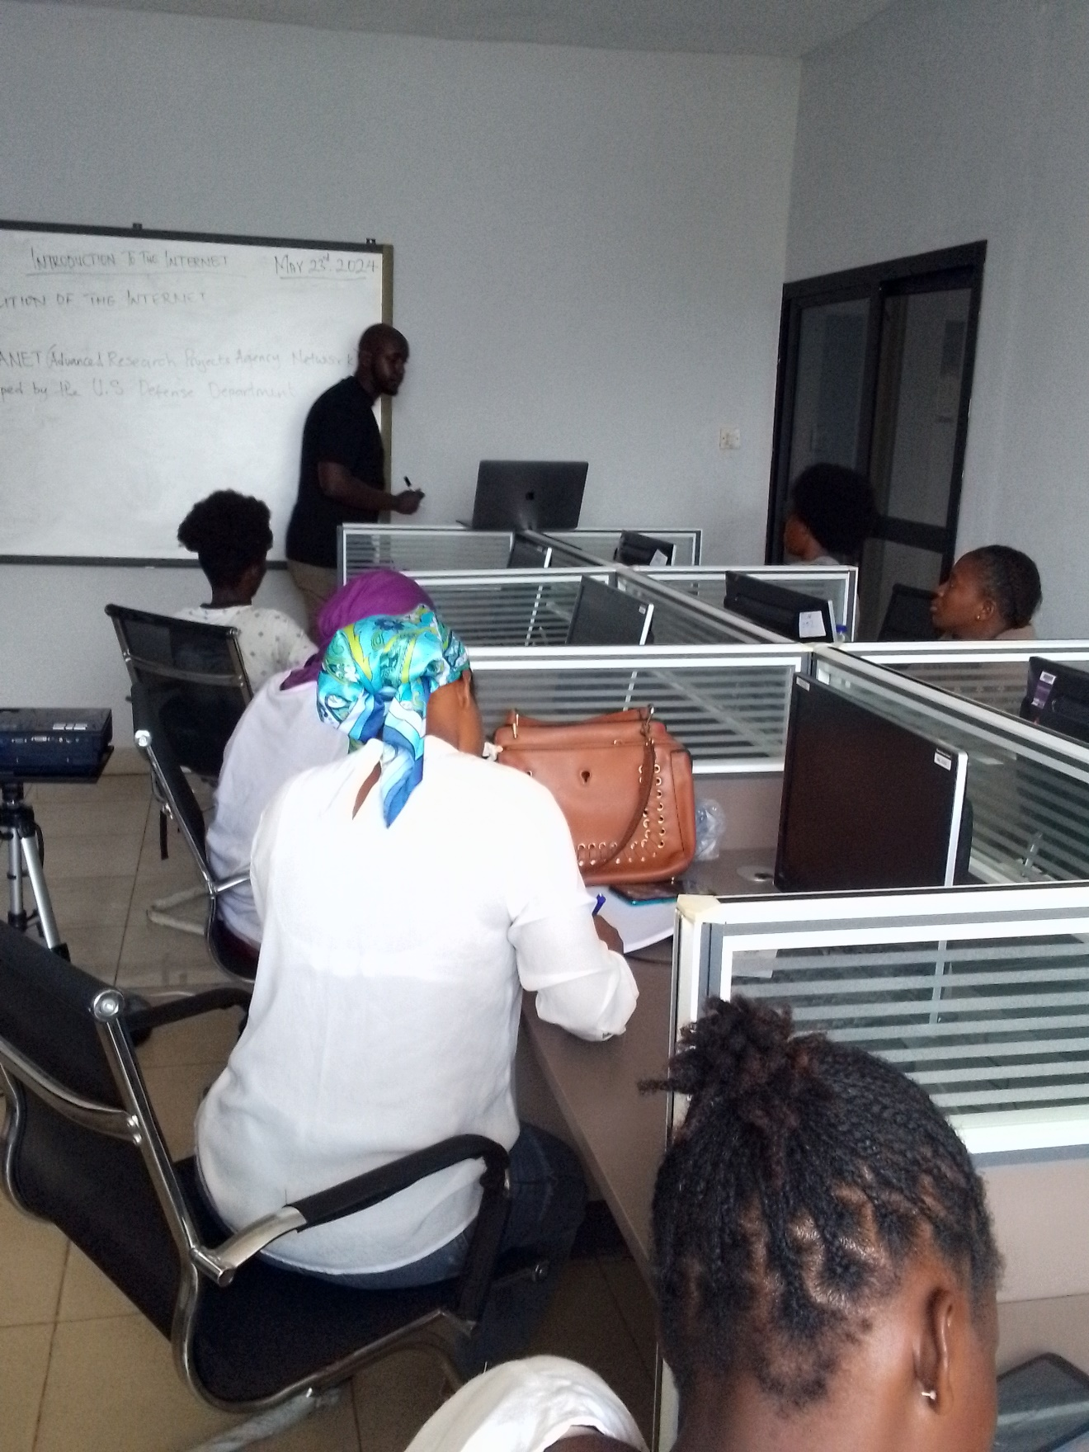

The DPC started with 28 trainees, with many reporting significant improvements in their digital proficiency. This initiative not only enhances employability but also empowers the youth to leverage technology for personal and community development. The lesson also provide certification upon completion, contingent on passing an exam.

**3. Request for Collaboration with National Council for Technical Vocational & Other Academic Awards (NCTVA):** To further enhance the value and recognition of our digital training programs, SCN has initiated a request for collaboration with the NCTVA. The primary objective of this collaboration is to secure accreditation for the certification of the courses offered at the DPC.

The certification process will involve:

* **Curriculum Review:** Ensuring that the DPC’s curriculum meets the standards and requirements set by NCTVA.
* **Accreditation:** Formal accreditation of our programs, providing participants with certificates that are recognized nationally and potentially internationally.
* **Quality Assurance:** Continuous monitoring and evaluation to maintain high educational standards and relevance to the job market.

This collaboration will significantly boost the credibility of our programs, making our trainees more competitive in the labour market and increasing their chances of securing employment or advancing their careers.

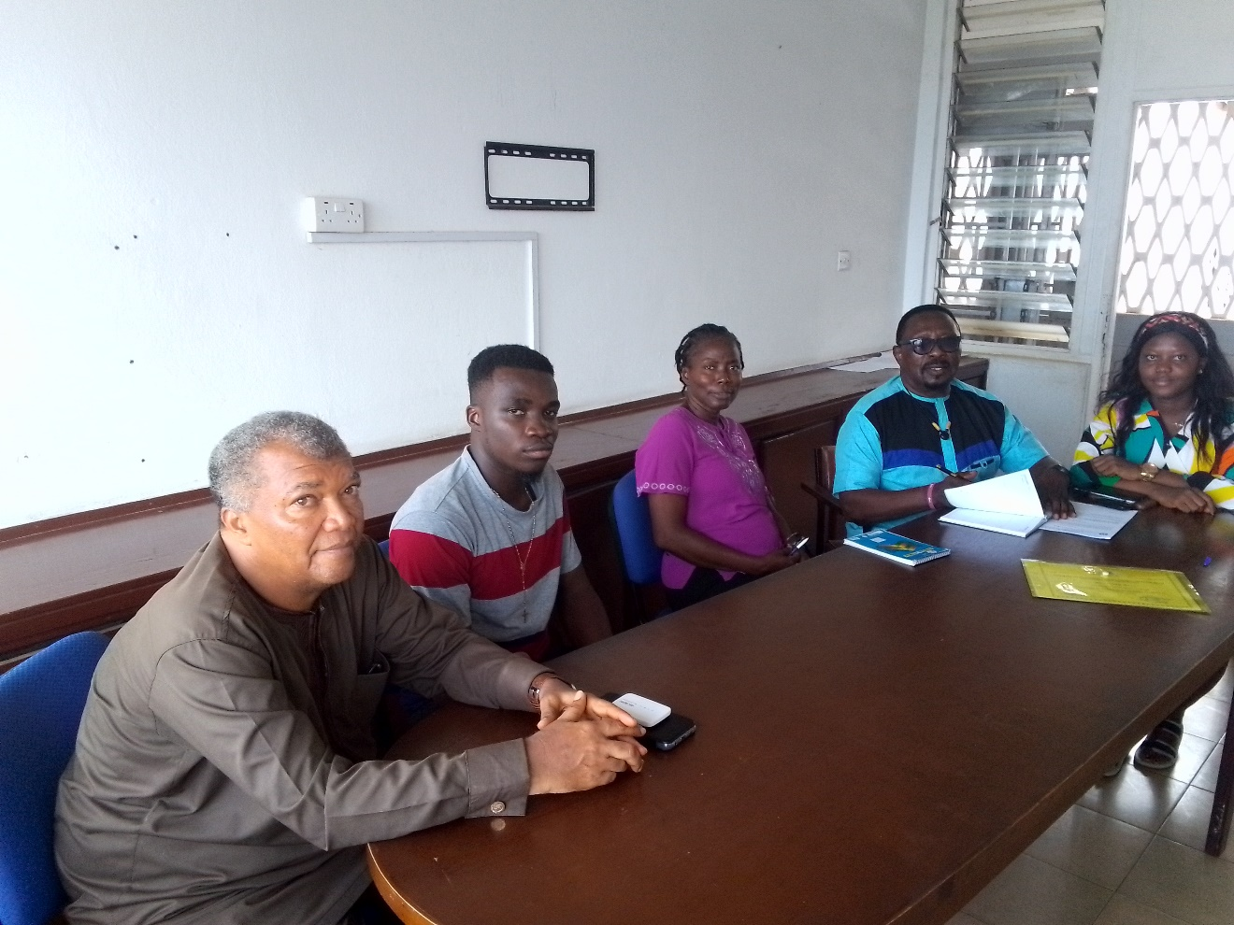

**4. Collaboration with the National Drug Law Enforcement Agency (NDLEA):** Recognizing the critical role of law enforcement in drug abuse prevention, SCN has sought to formalize a collaboration with the National Drug Law Enforcement Agency (NDLEA). On June 20, 2024, we submitted an official letter to NDLEA, accompanied by a draft Memorandum of Understanding (MOU), outlining the terms and objectives of our partnership.

The proposed collaboration aims to:

* **Strengthen Outreach Programs:** Utilize NDLEA’s expertise and resources to enhance our community education and outreach efforts on drug abuse prevention.
* **Joint Initiatives:** Develop and implement joint initiatives, such as workshops, seminars, and campaigns, to educate the public on the legal and health implications of drug abuse.
* **Support for Recovery Programs:** Provide support and training resources for individuals recovering from addiction, including providing basic computer literacy training.

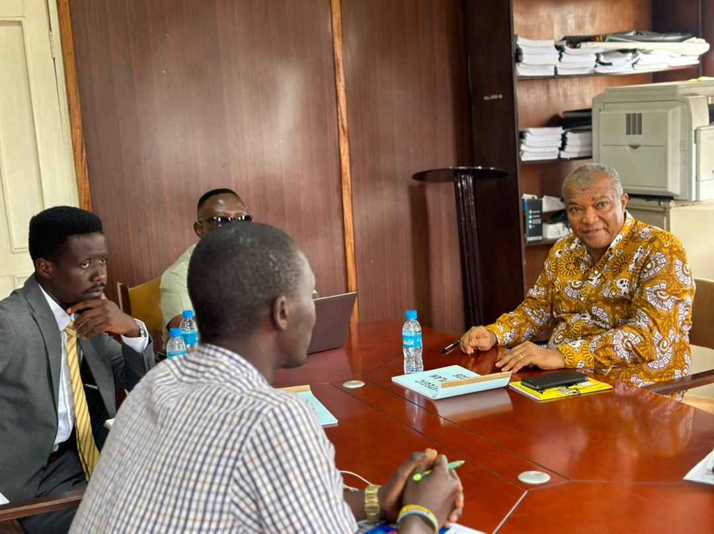

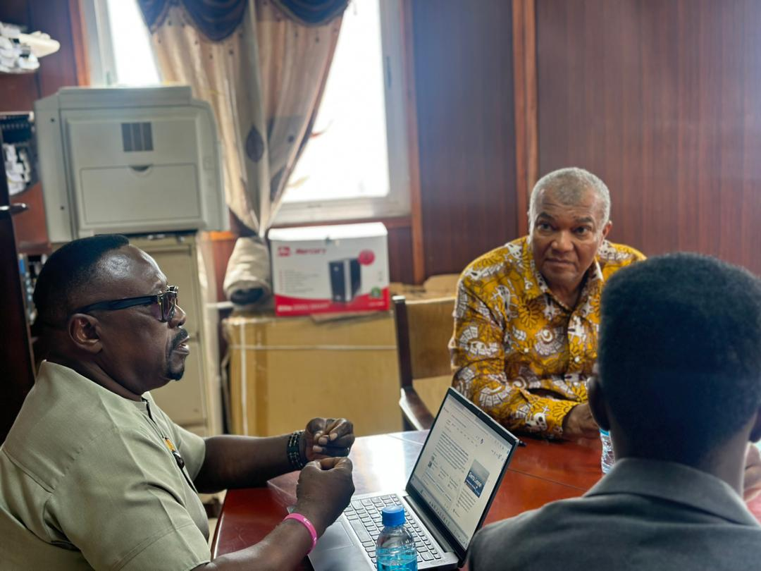

This partnership will enable SCN to leverage NDLEA’s capabilities, creating a more robust and effective approach to combating drug abuse in our communities.

**5. Cole Farm Community Flood Mitigation Cleaning Exercise (June 29, 2024):** On June 29, 2024, SCN organized a community cleaning exercise in the Cole Farm community, reinforcing our commitment to environmental sustainability and public health. The event aimed to address issues related to waste management, drainage cleaning sanitation, and community hygiene.

Key activities and outcomes of the cleaning exercise included:

* **Volunteer Mobilization:** Community youth including the DPC trainees, and SCN staff, participated in the exercise.
* **Waste Collection:** Collection and proper disposal of waste, significantly improving the cleanliness of public spaces, streets, and drainage systems.
* **Community Engagement:** Interactive sessions with residents to discuss ongoing waste management challenges and identify sustainable solutions.
* **Flood Mitigation Measures:** Drainages within the community were properly cleaned.

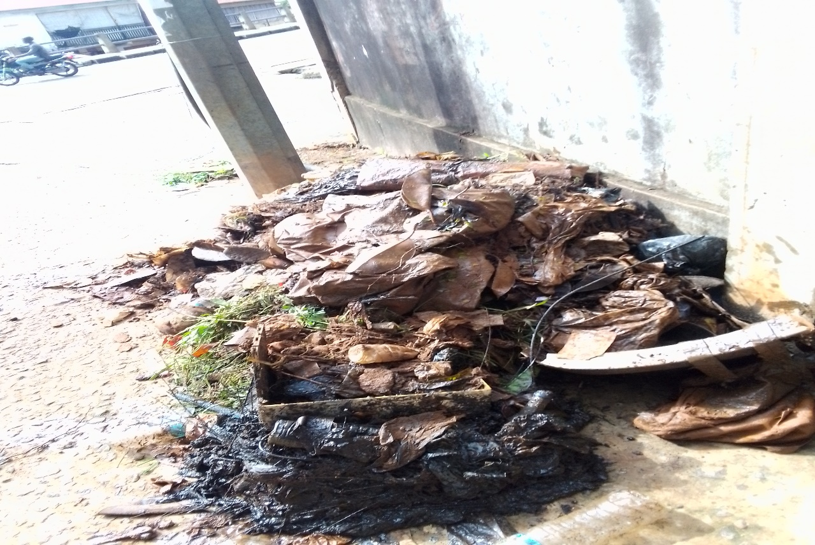

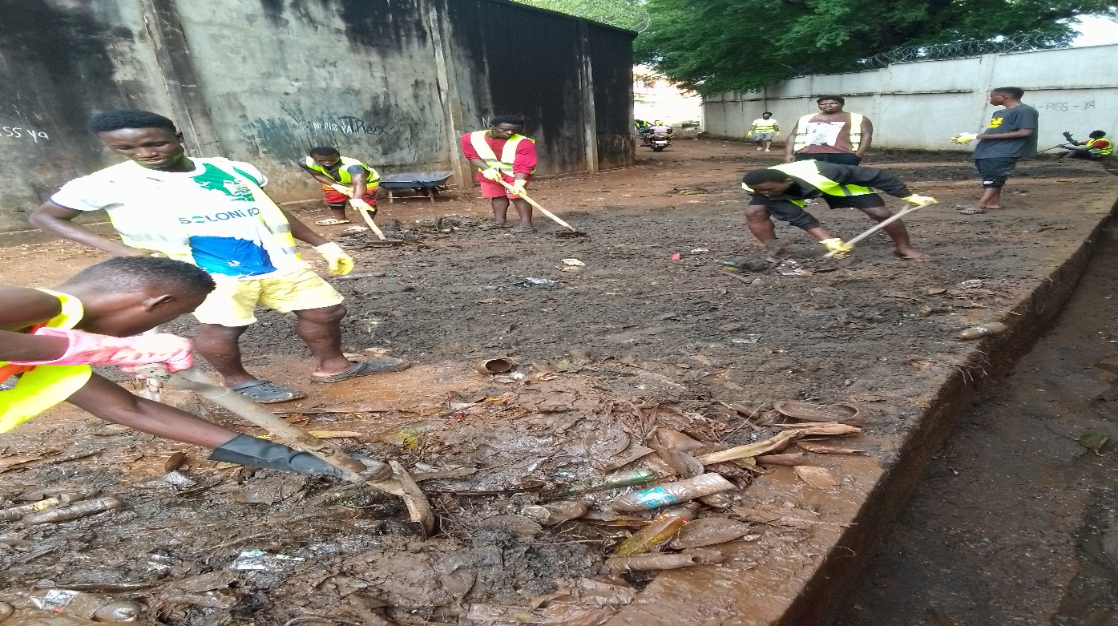

The cleaning exercise not only enhanced the physical environment thereby reducing the chances of flooding, but also promoted a sense of community ownership and responsibility towards maintaining a clean and healthy neighbourhood.

**Conclusion:** The activities and initiatives undertaken by SCN in this quarter reflect our unwavering commitment to community development, youth empowerment, and public health. We are dedicated to continuing our collaborative efforts with various stakeholders to create a sustainable and prosperous future for the communities we serve.

We look forward to your continued support and guidance as we strive to make a positive impact on the lives of the youth and the broader community.